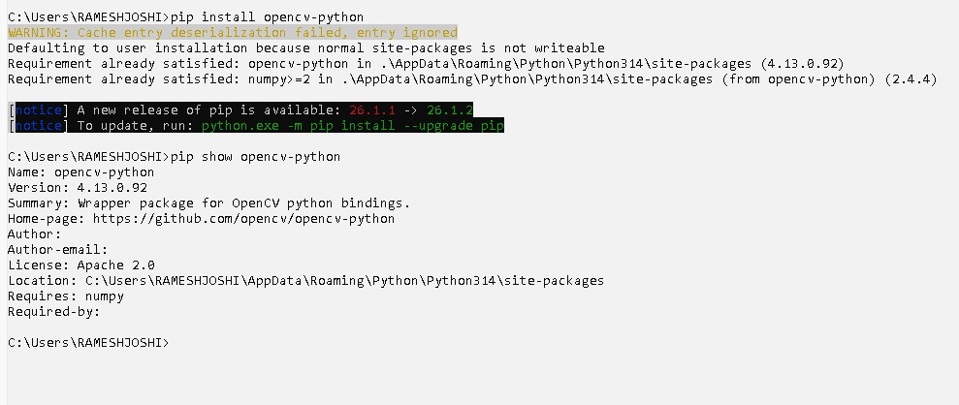
Screenshot of showing the pip install opencv-python.

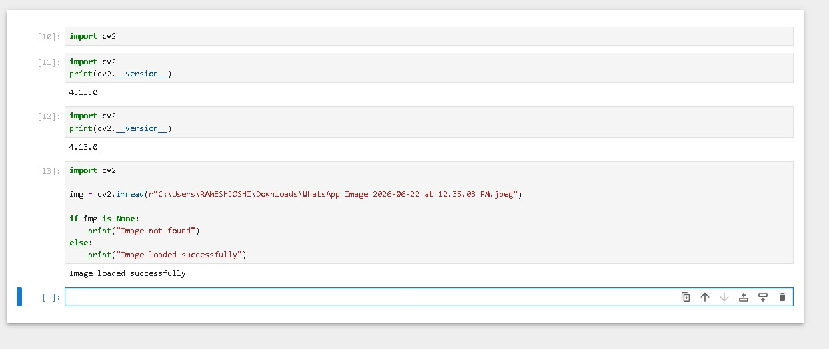
Image was loaded in the cv successfully. Done in the jupyter notebook

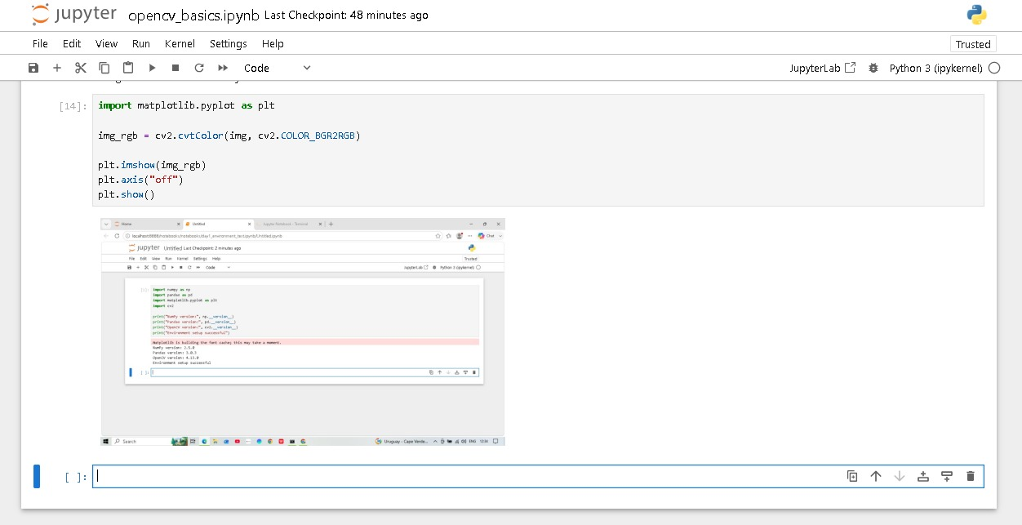
loaded image is displayed in the above screenshot.

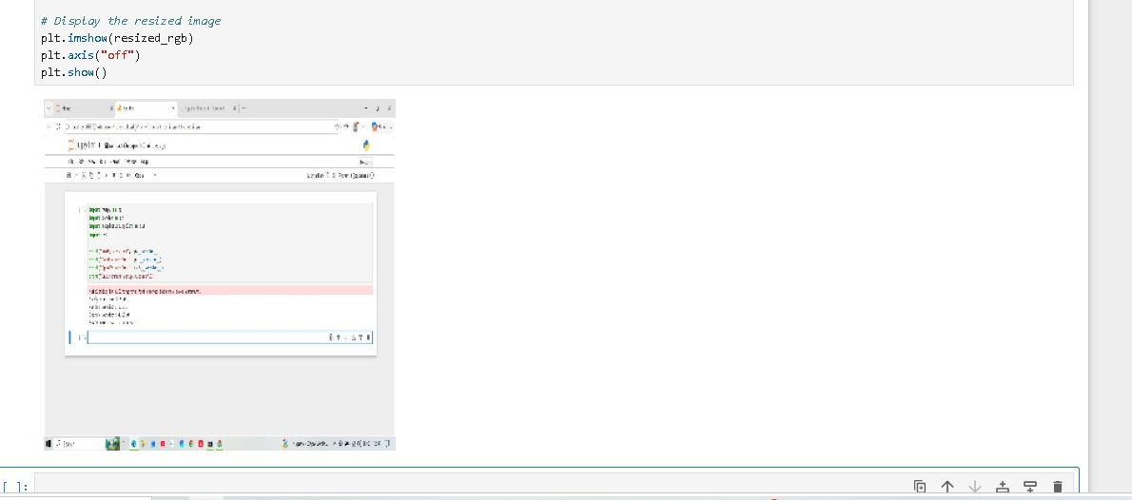Uploaded image is resized in the above SS.
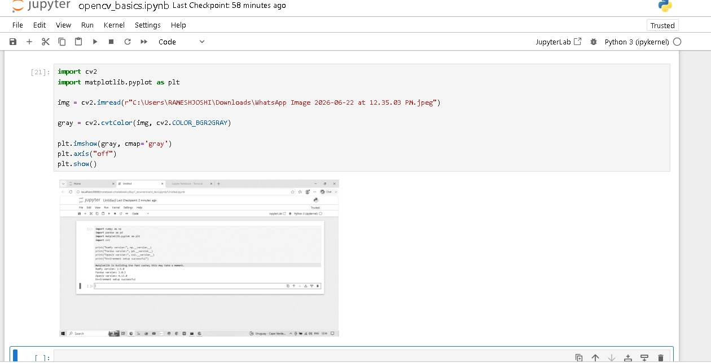
Uploaded image is Converted into the grid scale in the above SS.

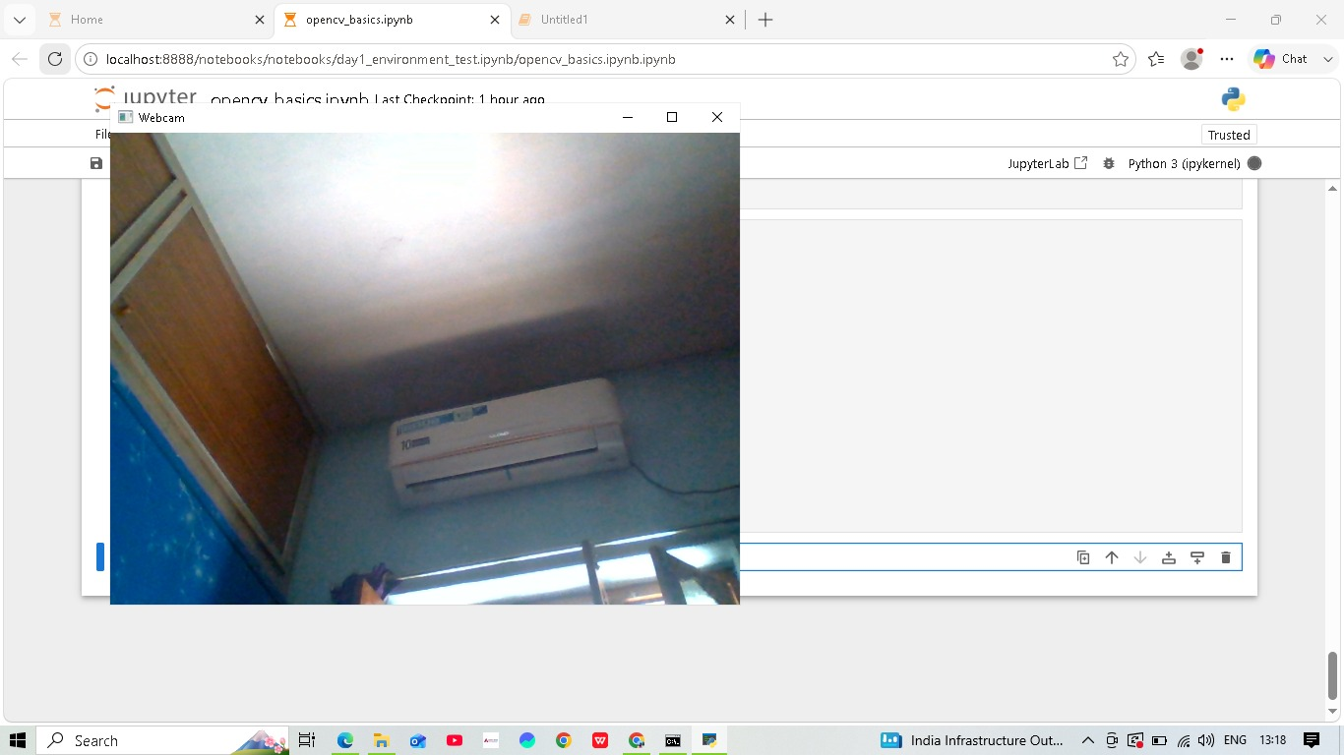
Web cam opened and started recorded live vedio.

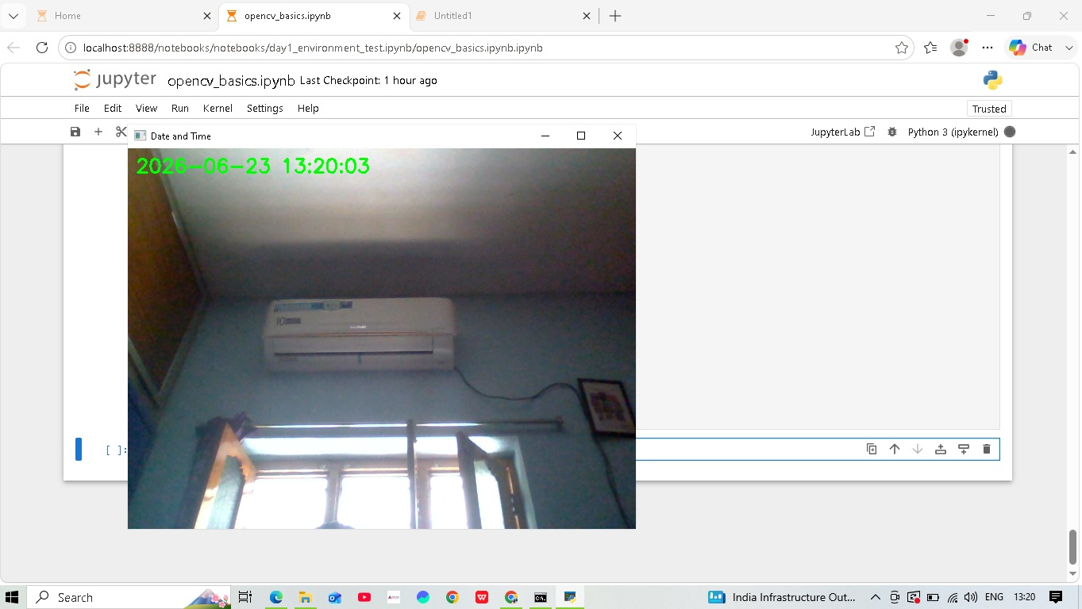
Web cam started recording along with the Date & Time.

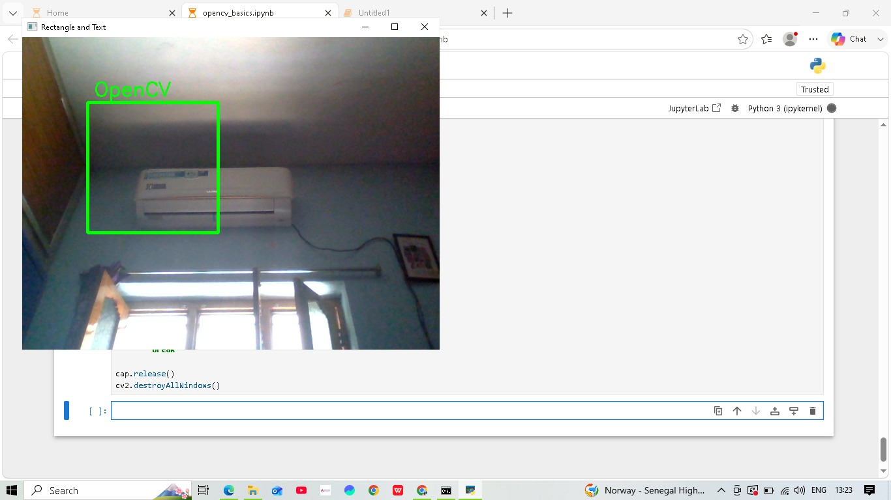
Rectangle has been drawn in the image which is captured by webcam.
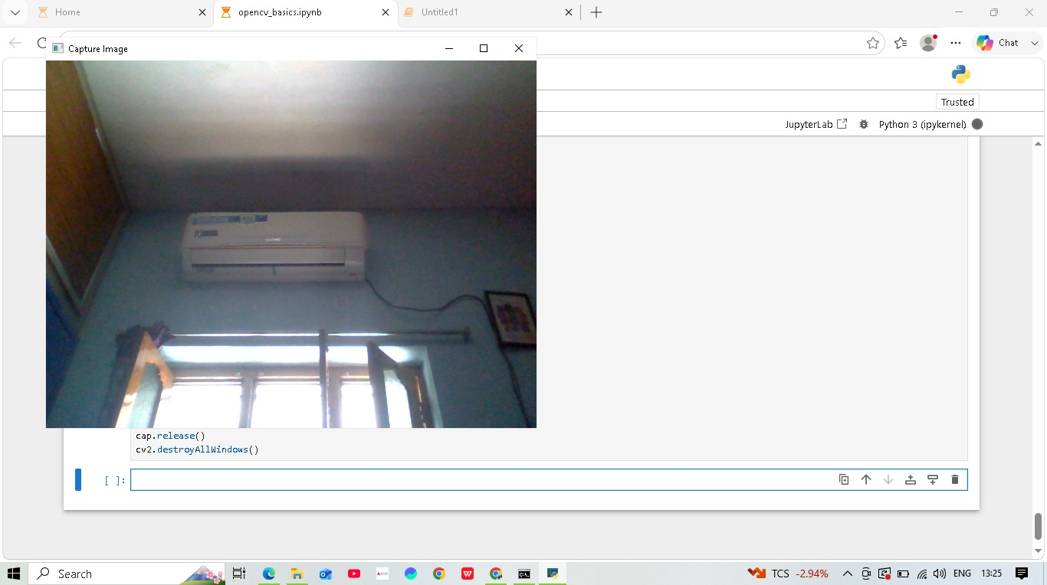
Captured image from webcam and saved locally .

